Regular Expressions
In a compiler, we need a precise way to describe which sequences of characters belong to each kind of token, such as identifiers, numbers, or keywords. The notation used for this purpose is called regular expressions, often shortened to regex. A regular expression is a compact way to describe a set of strings.
Before talking about regular expressions, we must first clarify the relationship between alphabets, strings, and regular expressions.
An alphabet is a finite set of characters. For example, an alphabet might be the set {a, b, c}, or the set of all letters and digits used in a programming language.
A string is a finite sequence of characters chosen from an alphabet. For example, if the alphabet is {a, b}, then "a", "ab", "bba", and the empty sequence are all strings.
The empty string is written as  and is the string with zero characters.
A regular expression is NOT a string. Instead, a regular expression describes a SET of strings. It is a rule or pattern that tells us which strings are allowed and which are not. The regular expression  matches only the empty string. Any single character from the alphabet, such as a, is a regular expression that matches the one-character string "a".
More complex regular expressions are built using three basic operators. If r and s are regular expressions, then 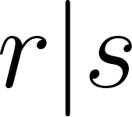 matches any string that matches either r or s, representing choice or union. If r and s are regular expressions, then  matches any string formed by taking a string that matches r and immediately following it with a string that matches s, representing concatenation. If r is a regular expression, then 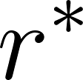 matches zero or more repetitions of strings that match r, including the empty string.
For example, suppose the alphabet is {a, b}. The regular expression a matches the set containing only the string "a". The regular expression a|b matches the set {"a", "b"}. The regular expression ab matches the set {"ab"}. The regular expression a* matches the set {, "a", "aa", "aaa", ...}.
In summary:
An alphabet defines which characters are allowed.
Strings are sequences made from those characters.
Regular expressions describe sets of strings.
Parentheses may be used to group parts of a regular expression and make the meaning clear. If no parentheses are used, operator precedence is as follows: repetition with *, then concatenation, then alternation with |. When in doubt, use parentheses to avoid ambiguity.
For example, consider the regular expression 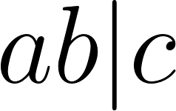. Because concatenation has higher precedence than alternation, this expression is interpreted as 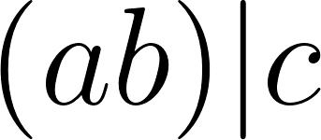. It matches either the string "ab" or the string "c".
If we instead want to match the string "a" followed by either "b" or "c", we must use parentheses and write 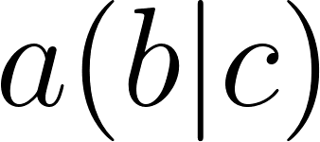. This expression matches the strings "ab" and "ac".
As another example, consider 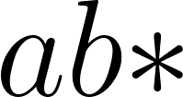. Since repetition has the highest precedence, this is interpreted as 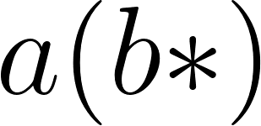, meaning it matches "a", "ab", "abb", and so on. It does NOT mean 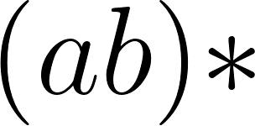.
To match repeated occurrences of "ab", we must write , which matches the empty string, "ab", "abab", and so on.
These examples show why parentheses are important for making the intended meaning of a regular expression explicit.

Lex/Flex Extended Regular Expressions
The basic regular expression operators introduced earlier are powerful enough to describe all regular languages. However, in practice, lexer tools such as Lex and Flex provide several extensions that make regular expressions shorter, clearer, and easier to write.

For a regular expression r, the expression 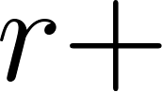 matches one or more occurrences of r. This means r must appear at least once. It is equivalent to writing . For example, 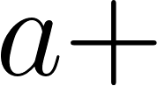 matches "a", "aa", "aaa", and so on, but does not match the empty string.

For a regular expression r, the expression  matches zero or one occurrence of r. It is equivalent to writing 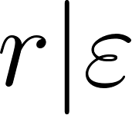. For example, 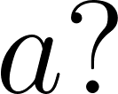 matches the empty string and "a", but not "aa".

Character sets provide a compact way to express choices among single characters. The notation 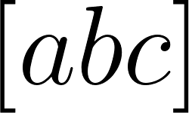 matches exactly one character, which can be "a", "b", or "c". It is shorthand for 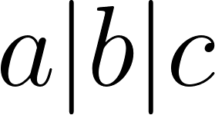.

Ranges may be used inside character sets. The notation 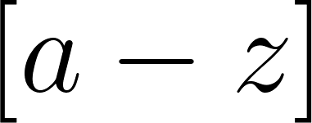 matches any single lowercase letter from "a" through "z". Similarly, 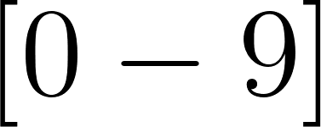 matches any digit.

A negated character set matches any character not listed. The notation 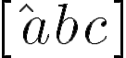 matches any single character except "a", "b", or "c".

The dot operator matches any single character except the newline character. It is equivalent to the character set [^\n].

Lex and Flex support many additional regular expression features. In this course, you are responsible for understanding the operators described here. Other features exist, but they are not required for this semester.

Lex extended regular expressions

Lex supports a set of extended regular expression operators that build on the basic regular expressions introduced earlier. Below is an almost-complete list of the regular expression constructs supported by Lex, along with their meanings.

A normal character such as c matches itself. For example, the regular expression c matches the string "c".

A backslash followed by a character, removes the special meaning of most operator characters and treats them as literal characters. Inside character sets and quoted strings, the backslash is also used for C-style escape sequences such as \n and \t.

A string enclosed in double quotes, written as 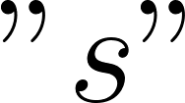, matches the exact string s. This is especially useful for multi-character operators such as "==" or "<=", and is often more readable than escaping each character individually.

A character set written as  matches exactly one character chosen from the set s. For example,  matches one of "a", "b", or "c".

A negated character set written as 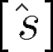 matches exactly one character that is not in the set s.

The dot operator matches any single character except the newline character. It is equivalent to the character set [^\n].

For a regular expression r, the expression  matches zero or more occurrences of r.

For a regular expression r, the expression  matches one or more occurrences of r.

For a regular expression r, the expression  matches zero or one occurrence of r.

For a regular expression r, the expression r{m,n} matches r repeated at least m times and at most n times.

Concatenation is written by placing expressions next to each other. The expression 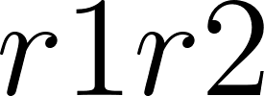 matches a string formed by r1 followed immediately by r2.

Alternation is written using the vertical bar. The expression 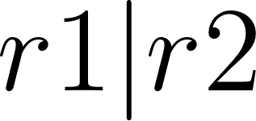 matches a string that matches either r1 or r2.

Parentheses written as 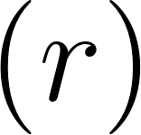 are used to group expressions and specify precedence. Parentheses do not match any characters themselves.

The lookahead operator written as 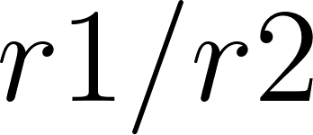 matches r1 only if it is immediately followed by r2. The text matched by r2 is not consumed.

The expression 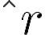 matches r only when it occurs at the beginning of a line.

The expression r$ matches r only when it occurs at the end of a line.

Avoid Common Regex Bugs

When doing homework or programming assignments, you usually discover mistakes by testing your code and fixing it. On exams, however, small misunderstandings about regular expressions can easily lead to wrong answers. The following are some common mistakes to avoid.

Square bracket abuse is a very common error. Students sometimes try to use regular expression operators inside square brackets, or use square brackets as if they were parentheses. Remember that square brackets define a character set and match exactly ONE character. For example, 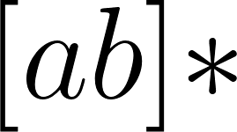 is valid and matches any number of "a" or "b" characters, but 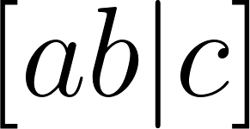 does NOT mean "ab or c"; it means one character chosen from the set {a, b, |, c}.

Another common mistake is misunderstanding operator precedence. Without parentheses, repetition has the highest precedence, followed by concatenation, and then alternation. For example,  means , not . When in doubt, always use parentheses to make your intent clear.

Writing a regular expression that is too loose is also dangerous. A regex that matches too much can consume input you did not intend to match. This is especially risky when using operators like , which can match almost everything. In a lexer, a rule like  can accidentally match an entire line or even the rest of the file as a single token.

Always be precise about what you want to match, and avoid patterns that are broader than necessary.

Some Regular Expression Examples
Regular expressions are the standard way we describe patterns of characters that define different kinds of tokens, such as identifiers, numbers, and keywords. In practice, the best way to understand regular expressions is by looking at concrete examples rather than abstract definitions.
Regular expressions are not only used in compilers. They also form the foundation of pattern matching in many common UNIX tools, such as grep, awk, and perl. If you have ever searched for text using patterns in these tools, you have already used regular expressions.
A natural question is: what regular expressions are needed to describe the tokens of a real programming language? For example, what patterns describe identifiers, numbers, operators, and comments in the C programming language? How do these patterns compare with those of another language, which has simpler lexical rules?
Finally, we must decide what the corresponding rules are for the language we are implementing this semester. Are its lexical rules the same as C’s, or are they simpler or different in important ways? Answering these questions will guide the design of our lexer.

lexical category | Kotlin | C
operators | +  -  ..  ..<  ...  ++  ||  ->  =>  += | For operators that are regular expression operators we need mark them with double quotes or backslashes to indicate you mean the character, not the regular expression operator. Note several operators have a common prefix. The lexical analyzer needs to look ahead to tell whether an = is an assignment, or is followed by another = for example.
reserved words | if  val  var  while  break  (In Kotlin, a bunch of reserved words are only semi-reserved and usable as variable names except in certain contexts. In k0 we'll just fully reserve them.) | Reserved words are also matched by the regular expression for identifiers, so a disambiguating rule is needed.
identifiers | ((Letter | '_') (Letter | '_' | UnicodeDigit)*)  | "`"[^`\r\n]+"\`"  We're not doing Unicode so UnicodeDigit can just become [0-9]. | [a-zA-Z_][a-zA-Z0-9_]*
numbers | Kotlin has a lot, maybe extended from newer C/C++. Hex and binary, etc. We care about a 113-level amount of constants. | 0x[0-9a-fA-F]+ etc.
comments | Kotlin allows nested comments, k0 we will settle for C-like non-nested. | C's comments are tricky regexp's
strings | Kotlin seems to have special rules for """ triple quote strings; study those. Kotlin has unicode character escapes that k0 will not need to support. We will support \t\n etc. | escaped quotes

Lexical Category | Kotlin | C

---------------------------------------------------------------------------------------------------------------------------------------

Operators | Kotlin has many operators, including some multi-character ones (examples: +, -, ++, ||, ->, +=, .., ..<, ...). | C has many operators too (examples: +, -, ++, ||, ->, +=, ==, !=, <=, >=, <<, >>, etc.).

| Important lexer note (applies to both): if an operator uses characters that are also regex operators (such as +, *, |, ., ?, (, )), we must write the operator in quotes or escape it so Lex treats it as a literal token.

| Also, many operators share prefixes (for example "=" vs "==", "+" vs "++" vs "+="). The lexer must look ahead and choose the longest match.

Reserved words (keywords) | Examples: if, val, var, while, break. Kotlin has some context-sensitive / “soft” keywords that can be identifiers in certain contexts. For k0 we will simplify and fully reserve them. | Examples: if, while, break, return, int, double, etc. C keywords are fully reserved (cannot be used as identifiers).

| Important lexer note (applies to both): keywords match the same character pattern as identifiers, so we must disambiguate: treat certain matched identifiers as keywords.

Identifiers | Kotlin (spec-style): $$((Letter|_)(Letter|_|UnicodeDigit)*)$$ and Kotlin also supports backtick identifiers like $$`[^`\\r\\n]+`$$. Kotlin identifiers can use Unicode letters/digits. | C (classic lexer rule): $$[a-zA-Z_][a-zA-Z0-9_]*$$. C identifiers are typically ASCII letters, digits, and underscore (language standard allows “universal character names”, but most teaching lexers treat it as ASCII).

| In k0 we will not do Unicode, so we will use the C-style rule.

Numbers | Kotlin supports many numeric literal forms (more than we need in a 113-level subset), including decimal, hex, binary, underscores in digits, and suffixes. | C supports decimal and also hex literals like $$0[xX][0-9a-fA-F]+$$. C also has octal forms and floating-point forms (and optional suffixes).

| For k0 we will support a simpler subset (e.g., decimal integers, optional hex, simple reals if needed).

Comments | Kotlin has line comments starting with //, and block comments /* ... */. Kotlin block comments can be nested. For k0 we will simplify to non-nested C-style comments. | C has line comments // and block comments /* ... */. C block comments are NOT nested.

| Practical note: block comment regex is tricky; many lexers handle it using a separate comment state rather than a single giant regex.

Strings | Kotlin supports normal quoted strings "..." with escapes ("He said \"hello\""), and also triple-quoted strings """ ... """ with different escaping rules. Kotlin has Unicode escapes. | C supports "..." strings with backslash escapes (e.g., \\n, \\t, \\" , \\\\). C does not have triple-quoted strings.

| For k0 we will support standard quoted strings with common escapes like \\n and \\t, and allow escaped quotes.

When we compare C with a simpler language, we often find that the simpler language has fewer rules and fewer special cases. It may have fewer operators, fewer number formats, and simpler rules for comments and strings. As a result, its regular expressions are shorter and easier to understand.

This comparison helps us see that designing a lexer is largely about deciding how complex the language’s tokens need to be. For this course, we intentionally choose simpler rules so that we can focus on the core ideas of lexical analysis without getting lost in language-specific details.

